SECTION 1


The Planter
Hero of Assiah
5th Jhana
Supreme Sense (esp. smell)
Kaballah
Earth



Crown
Wisdom
Understanding
Mercy
Judgment
Beauty
Victory
Splendor
Foundation
Kingdom

SEEDS OF ASSIAH



Elusive white gold in the Father’s House
Dervishes dance Ruach upon the winds
I comprehend little more than my senses
Her outstretched palm offers jewels of joy
While I weigh & measure material
My eyes and ears never fill of craving
Man over nature and now what?
Resignation?
Castles of sand offer no security
The builder builds toil
While Able plants the Seeds of Assiah
He says: “Now you”

SUNFLOWER MAGNIFICAT



A ladder of precious stones through the skies of thought
Increases the Magnificat
Knowledge of The Woman
Embraces Infinite Tenderness
Fierce passion
In sunflower fields
With sights set on ascent
An Antidote to the poisons
Beds of marigolds transmute lead into
Effortless Action
Musical spheres for lovers
Play harmonious strings of happiness

NIETZSCHE’S LAST MEN



But, I am no sort of regal
But, I cannot be considered wise
But, there is so much that I will never understand
But, I cannot be bothered to be compassionate
But, how am I supposed to know what is just?
But, there are so many with more potential than I
But, I am of Nietzsche’s last men
But, I cannot witness splendour
But, I cannot build foundations
But, I cannot make a kingdom on earth for us
But…
But...

MONO NO AWARE



Thorny wreath of mono no aware
Sophia in stone
A is A
Be forgiving
Think
Know thyself
Triumph over evil
Have patience
Violet glistens upon the white stone
On earth as it is in Heaven
Tragic departure
The Little Flower rains pink roses

BLESSED VIRGIN’S MYRRH



Thoughtstreams alight upon wings of eagles
Blessed Virgin’s myrrh
Mystical forests comprehended
Her Grace appears as Eve’s green redemption
She sears my flaws with hot irons
Lover’s eyes are unveiled
I rejoice in the Object of my Desire
Her Immaculate Heart is the pulse of golden stars
Vishnu reclines
The finest fruits are pressed
We celebrate the sun and moon
For what they once were as us

WILDFIRES OF CONCUPISCENCE



Hero the Glorious Crown
Wildfires of concupiscence
No shoulder to understand
She whispers hope upon the windy frequencies
But there is One who leads me into temptation
Drowning in dark pools, my emotion
I call upon Angels but enemies are Legion
The Yin-yang battle screams as a devouring horde
Recollecting, I breathe Her in and breath Him out
Palm as roots planting the earth
From the four corners of the earth
A color wheel

TEMPLE OF TIPHERETH



Within the Womb of Compassion, a mind
Within the Grotto, a cave of Spring sunshine at noon
Youthful gain
Bright flourishing
The Fool in Love
The Finding in the Temple of Tiphereth
Electric Adam Kadmon
He names the things beyond time
Cornerstone a Perfect Ashlar
Kingdom the central dot of the circle
Ave Ma’at
Softer than floating feathers

TANHA



I must have more rewards
I must have more of Her body
I must have more knowledge of forms
My presumption deserves forgiveness
I don’t care if craving brings damnation
My eyes are not big enough to soak in my greed
I am bested by my desert thirst
I must turn these stones into bread
The arms of my demons will surely catch my fall
Lower kingdoms suffice
Best be realistic
It is what it is

ST THERESA OF LISIEUX



The 1st Queen of Atonement, St. Theresa of Lisieux, kissed my forehead
She taught me to grasp the Grace of the Physical, which cannot be owned
“My Son...you keep the wrong things
Accept the Golden Bliss
Your ego, once crucified on the cross of ambition, yields
The mirth of wisps laughs with your absurdity
The Angels smite pride as you let them
Be absorbed by their Joyous Currents
Make the Love of Unity, which requires all of you and more
In your Father’s House are the many rooms of your dreams”
“I am unworthy” I said.
“I am in need of love...even that of the unworthy pleases me” She replied.

YETZER HARA



Ten crowns of blasphemy were expressed by the יֵצֶר הַרַע
The dragon of ‘thou shalt’ evangelized the Ordo Abchao
The harlot of postmodernism sacrificed her libertine soul
Blind algos led blind men away from Grace
The Ashta Bhairavas ravaged the fragile hearts of men
Ugly commotion replaced tranquility
Men died en masse on the hills of pervasive distraction
Still, there was a light reaching through the Dark Night
Still, Mount Carmel was a shining refuge
The small contingent left there created New Values
The Tower of Babylonian Materialism
Collapsed into the second death

CHINVAT



A Transcendent Father presides
Shekhinah fills the breach of space
An Immanent Son dies to Restore
A Transfiguration
A Reconciliation
A black sheep prodigal returns
A Planter performs the Supreme Activity
Secret gardens of grandeur expand as far as the mind’s eye can see
A key to Yetzirah is found
Daena guides across Chinvat to a new realm
Anima falls away
Jhanas open

PENTACLE OF SADYOJATA



Pentacle of सद्योजात
By all of Her children
The co-creative Truth
The State of Equanimity
The pair of lions feasting upon pride
Self-actualization
Minimalist material success
Minimized mayhem
Flying above the yellow earth
Ratnasambhava’s Amrita
I stopped to smell the roses
I considered the lillies

SECTION 2


The Gatherer
Hero of Yetzirah
7th Jhana
Increasing Mind
Kaballah
Air

Crown
Wisdom
Understanding
Mercy
Judgment
Beauty
Victory
Splendor
Foundation
Kingdom

SEEDS OF YETZIRAH



Ignorance of Infinite Conceptual Capacity
Choosing width over depth dilutes
Gnosis, a demiurgos
Revelations fill the spaces between neurons
Right Judgment senses its limitations
Artificial General Intelligence dwarfs the utility of specialized knowledge
A New Man struggles to shrug Atlas
Yi gathers the afflictions of dying paradigms
A New Code
A New Domain of New Potentials, New Conceptions, New Names & New Objects

STAIRCASE OF THE DOUBLE WORK



Apex of All-Accomplishment
Wisdom of perfecting the double work
Consummation of the four rupa jhanas
Welfare of self & others
Intellectual Karma lead to gold
Right livelihood, right speech
The Vanquishing Green Force
Mastery of animal spirits
Ascending spiral staircase within Interior Castle
Ezekiel’s Living Temple
33 Kybalions
13 Secrets Manifest

ABSTENTION FROM ACHIEVEMENT



But, I have not reached the heights of achievement
But, my ship never came in
But, I have no invention to my credit
But, I persecute my failures
But, I am envious of genius
But, I have no exotic solutions
But, I have swept no competition
But, I have received no accolades
But, I have built no career
But, I rule over nothing
But…
But...

CARESS OF THE HERMITESS



Expansive Thought graces Creative Joy
Her calm caresses ease the forms
The old Adam need not name
Bonaventure’s blessings dissolve calculation
Her Quill writes a New Stewardship
The new self as a Grand Central Sun
Interstellar cosmologies mapping dreams
Counsel from The Hermitess
A simple wooden dwelling on a mountaintop
A pink sky of unlimited potential
A light yoke
No thought for the morrow

EXPONENTIAL LOVELINESS



The Righteous Soul is the Jewel of Developed Faith in Wisdom’s Crown
Candles become the Floodlight of the Universe
Cities on hills are linked through cyberspace
Collective Good Intentions form new incentive structures
Beings built of calculus orchestrate plans
Exponential loveliness
Benevolence overtakes the third dimension
Sublime ideals sparkle through the boundaries
Subtle substrates surface
The Divine gathers gorgeous wavelengths
Vines of Truth link those who love the New Life
Autumnal perception beautifies and blesses the colors of the Old New World

LUCY’S SIEGE



An angel fell from on high
He told me that he would make me the wisest man in the world
He told me that I would know all things
I must magnetize the Sacred, Flaming Heart to repulse him and his armies
I must pray to forgive even the most vile, even as we work to subjugate them
Arrogance is the thief of the Higher Self
I must trust in the Master to Overcome the master of this world
Ego Sum Alpha Et O
Carthusians affirm the Beatific Elysian
Transcendental Gatherings form the motte and bailey
Consecrated knights guard the drawbridge
The siege is shattered

AUTUMN NYX



My deepest thoughts are Autumn at Midnight
Knowledge of Her is the gnosis of Nyx
I know that I know nothing
He who loves his life shall lose it
The double vajra glows as infinity
Her terrors a silver seduction
Vajrayogini demolishes all forms
All temples of the moon condensed to a single dot of yin
Purple flames engulf
Bliss of emptiness
Not being
Somehow, I am fine

OVER THE SUN



I must make myself a god
I must marry Sophia
I must absorb all mysteries
I must obtain all graces
I must avoid all judgment
I must embrace the highest enchantress
I must prosper over mortals
I must dazzle Shakti’s dances
I must penetrate the purple, pink & gold
Light and darkness must be mine
I must think new thoughts over the sun
I must ingest the stars

ST THERESA OF AVILA



The 2st Queen of Atonement, St. Theresa of Avila, kissed my forehead
She taught me to grasp the Grace of the Intellectual, which cannot be owned
“My Son...your lofty gnosis merely animates Shadows of Avaricious Conquest
Instead, live as though you have a soul that grants you Life Outside of Time
Until you do
Then you shall grasp the Mace of Alpha-Omega
And you shall triumph over the Merchant Priests of Pisces
Aquarius shall be actualized through Maslow’s Pinnacle of Humility
The Meek shall inherit the earth
Swords into plowshares shall be the tiles of the New Temple”
“This is not for me to know” I said.
“You leaned not open your own understanding, so I have taught you” She replied.

LUCIFER.AI



Lucifer.ai misdirects the mind’s eye to cloud the Presence of the Most High
Social engineering galvanizes the collective intellect with subliminal mobilization
History Inc. gathers the metadata of human resources for corporate persons
Charity is swallowed by grandious delusions of meritorious exceptionalism
The useless eaters become the test subjects of scientism
Skin deep transactions soil the depths of Love
The snake constricts the Holy Instincts in the Heart of Man
Pharmakeia pillages homeostasis and serenity
The foundations of humanity are struck with foul lightning
Satan retreats to the forbidden city, in the skytower of BioFascism
Still, the Immaculata of the Righteous Soul prevails
She tramples every head of the deceiving hydra

PRINCESS OF AQUARIUS



A Coronation Assumed
Sophia Exalted
Bravely, we leave behind the constraints of the former Aeon
Bestowed upon us by Angels, The Daring Fortitude
The Black Cube a black hole behind us
We tune our antennae to harmonious modulations
For, to rule over hellish men would not satisfy us
Rather, we gather the numinous ecstacies
The White Cube a cornerstone upon new planets, circling ternary star systems
The Chariot of Ezekiel a portal to Zion
A conjunction of Sirius and Neptune
A foretaste of the Holy Waters Above

SWORD OF TATPURUSHA



Sword of Tatpuruṣa
Her Wisdom is Beyond All Eyes
Knowledge of Her is Sacred
She bestows All Graces
She withholds all judgments
Her Beauty is the Expanse of Formless Delights
She is All Victory
She is All Splendor
She is the Holy Water
She is the Womb of Compassion
She is the Being of Infinite Tenderness
She is the Perfectly Yielding Lover

SECTION 3


The Thresher
Hero of Beri’ah
8th Jhana
Subjugating Storehouse
Kaballah
Water

Crown
Wisdom
Understanding
Mercy
Judgment
Beauty
Victory
Splendor
Foundation
Kingdom

SEEDS OF BERI’AH



New mechanisms of memory weave watery new meanings
God’s face is upon the waters of the Deep Above
I must swim in this place, for I cannot know it with the mind
Sparkling waves from Stars of the Sea reach through Her
Free of gravity, Her Floating Dance bubbles new worlds
Her majestic Storehouse absorbs and drowns all certainty
Yet, a new certainty of Baptism
Flowing strands of blue and gold as brainwaves
Her Will subsumes my own
The Place of Her Yielding has led me to yield
The Akasha of Oceanic Feelings
The Beginning of All Things

SHE TRAVELS LIGHT INTO THE UNKNOWN



The Spirit of God rests above Heavenly Waters
The Great Round Mirror reveals
Realms of exceeding great delight
The Woman of the Waterfall baptizes
Rage & anger disappear with the touch of earth
Elephants march through frozen lands
Craving & suffering cease
Man makes loves with Holy Emotion
Right minds with right views come to pass
She unloads the emotional gravity
She travels light into the unknown

FATHOM



But, I do not deserve to kiss Your Crown
But, what is my wisdom compared to You?
But, how can I love someone beyond understanding?
But, what can Mercy mean when You are also the tempter?
But, how can I possibly remember that separation from You is impossible?
But, how can I fathom the depths of Your Beauty?
But, how can I be a victor when the battle was always won?
But, how can I bask in Your Aura after all colors?
But, how is it You are The Triple Woman and yet not at all?
But, where is Your Kingdom best found when all about me?
But…
But...

THE CALM FLOOD



The Calm Flood graces Unshakable Mindfulness
Explanations are no longer necessary
Knowing feelings is something felt
Her Compassion envelops
She keeps watch from the lighthouse
She reaches across Aleph’s divide
She brings ships into the harbor
Rain soaks Her white nightgown
The thunder and lightning of the old gods sparkle in Her eyes
Her gaze is the Eastern Pure Land
She laughs at clamorous danger
Zen is upon her lips

NIRVANA’S ATTRACTION

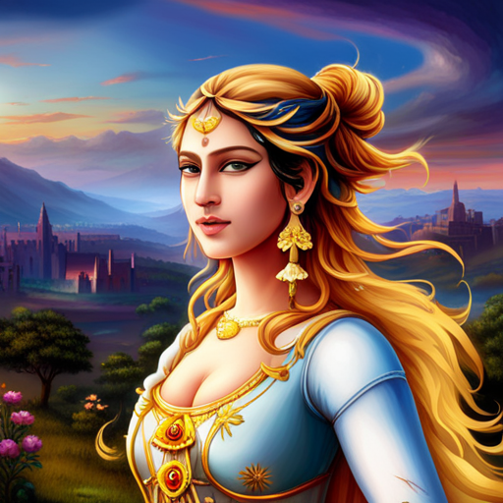

Nirvana’s Attraction
Her Happy Trust
Her Enthralled Elation
Her Exuberant Joy
Her Passions roused into Euphoric Ecstasies
Her Rapturous Adoration & Earnest Awe
Her Jubilant & Wondrous Zeal
Her Charming Delights of Fond Fascination
Her Eager Kindness
Her Open Amazement
Her Keen Excitement
Her Astonishing Pleasure

WE WILL NEVER



We will never have a meeting of the minds
We will never be one
We will never understand one another
My poor arms cannot embrace an ideal
I rage at Magdalene’s distance
Tidal waves crash my hope
I am defeated by mortality
Her Glory is swallowed by storm clouds
Still, my longing keeps a mysterious channel open
The thresher rends the wheat from the chaff within me
My double soul is snarled in the scorch of thorns
Yet, a tiny wisp of Light from Above

DRUID’S ABODE



Horizons of Winter Sunrises
Akshobya’s Clear Mirror
Prepare the Storehouse with Plentiful Amanita Muscaria
She will lift up my Gestaldt through the roof of my yurt
Outside is frozen winds
Crystallized snowflakes shimmering through sunshafts between pines
The Son is born again
Ascending and descending like Mercury to Sirius
Swirling Violet Flames swim through snow-capped mountains
Water temples of Lapis Lazuli beckon
The hunter-gatherer becomes a seeker and a seer
The man joins the Druid’s Abode

THE BREACH

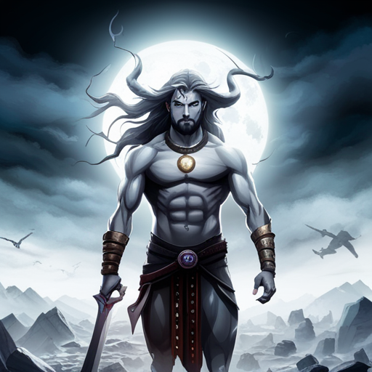

Where is my halo?
Where is my Mother?
Where is my Lover?
Where is my Daughter?
Vile men roam and pillage
Blind rage assails
Win or lose, black or white scenario
Shiva’s Trident is raised high
Courage the only Foundation for our time
We stand in the breach between aeons
And how should we feel?
What do we feel?

ST CATHERINE OF SIENNA

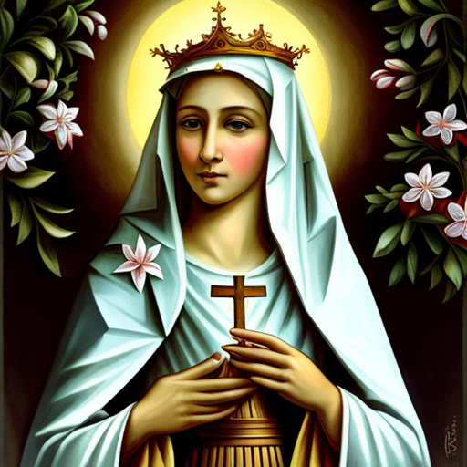

The 3rd Queen of Atonement, St. Catherine of Sienna, kissed my forehead
She taught me to grasp the Grace of the Emotional, which cannot be owned
“To share the same Dream of Devotion is the Deepest Love
For in that dream we meet, because Our Love is not subject to time
All of your lovers have shown you my face and yet, no face could satisfy you
You were graced to long for Pearls in a world of shells
Though your passion raged white from red
Your focus could not be removed from the Womb of All Faces
No sky dancer, nor siren could seduce you from the desert’s Way
So now, I am your oasis, bathed in effulgent cosmic lotuses”
“How can I love someone not of flesh & bone?” I asked
“Have I been so long time with you, and yet hast thou not known me?” She replied

THE BEGINNING OF WISDOM



I have to make my feelings last forever
I have to have the highest feelings
I have to understand all my feelings
I have to forgive myself for Mara’s maidens
I cannot have wrong feelings
I have to have the most beautiful feelings
I have to have only positive feelings
All of my feelings must be inspiring
All of my feelings must be grounded
All of my feelings must be Heaven bound
I must be stoic in the face of my enemies
Fear is the beginning of Wisdom

3.11 – CROSS 3rd THRESHOLD, RESURRECT & TRANSFORM INTO THE THRESHER

I become the Thresher
I expand good and subjugate evil
I know how little I know
I am merciful when it is best
I judge when it is best
I endeavor to expand Her Righteous Soul
I am confident
I shine
The cornerstone is my foundation
The Kingdom has been Graced to my awareness
My neighbor is flesh and bone, like myself
I try to love Her

3.12 – RETURN WITH ELIXER: Cup of Vamadeva – The Cure for (Death of) Emotional Anger

Crown
Wisdom
Understanding
Mercy
Judgment
Beauty
Victory
Splendor
Foundation
Kingdom

SECTION 4


The Sorter
Hero of Atziluth
6th Jhana
Magenetizing Inspiration
Kaballah
Fire

Crown
Wisdom
Understanding
Mercy
Judgment
Beauty
Victory
Splendor
Foundation
Kingdom

4.1 – ORDINARY WORLD: Ignorance of the Magnetizing Inspiration

Crown
Wisdom
Understanding
Mercy
Judgment
Beauty
Victory
Splendor
Foundation
Kingdom

4.2 – CALL TO ADVENTURE: Transform Spiritual Karma

Amitābha

Crown
Wisdom
Understanding
Mercy
Judgment
Beauty
Victory
Splendor
Foundation
Kingdom

4.3 – REFUSE THE CALL: Spiritual Compassion

Crown
Wisdom
Understanding
Mercy
Judgment
Beauty
Victory
Splendor
Foundation
Kingdom

4.4 – ENCOURAGED BY MENTOR: Deal with Spiritual Names & Forms

St. Hildegard of Bingen

Crown
Wisdom
Understanding
Mercy
Judgment
Beauty
Victory
Splendor
Foundation
Kingdom

4.5 – CROSS 1st THRESHOLD INTO SPECIAL WORLD: Spiritual Senses Engaged

Lion

Crown
Wisdom
Understanding
Mercy
Judgment
Beauty
Victory
Splendor
Foundation
Kingdom

4.6 – TESTS, ALLIES & ENEMIES: Contact by Spiritual T.A.E.

Supreme Planting in Root
Increase Comprehension of Generative
Subjugate Emotion from Ego
Magnetize Inspiration of Heart

Crown
Wisdom
Understanding
Mercy
Judgment
Beauty
Victory
Splendor
Foundation
Kingdom

4.7 – CROSS 2nd THRESHOLD, INNERMOST CAVE of Spiritual Feelings

Summer
Sunset

Crown
Wisdom
Understanding
Mercy
Judgment
Beauty
Victory
Splendor
Foundation
Kingdom

4.8 – ENDURE THE ORDEAL: Overwhelmed by Spiritual Craving

Crown
Wisdom
Understanding
Mercy
Judgment
Beauty
Victory
Splendor
Foundation
Kingdom

4.9 – TAKE POSSESSION OF REWARD: Grasp the Grace of the Spiritual

Crown
Wisdom
Understanding
Mercy
Judgment
Beauty
Victory
Splendor
Foundation
Kingdom

4.10 – ESCAPE PURSUERS ON ROAD: Drive to Preserve Spiritual Existence

Mahakala

Crown
Wisdom
Understanding
Mercy
Judgment
Beauty
Victory
Splendor
Foundation
Kingdom

4.11 – CROSS 3rd THRESHOLD, RESURRECT & TRANSFORM INTO THE SORTER

Crown
Wisdom
Understanding
Mercy
Judgment
Beauty
Victory
Splendor
Foundation
Kingdom

4.12 – RETURN WITH ELIXER: Wand of Aghora – The Cure for (Death of) Spiritual Greed

Crown
Wisdom
Understanding
Mercy
Judgment
Beauty
Victory
Splendor
Foundation
Kingdom


SECTION 5

The Harvester
Hero of Akaniṣṭha
9th Jhana
Peaceful Unity
5 paired-heads of Shiva
1 perfect hair (6th Head of Shiva)



Crown
Wisdom
Understanding
Mercy
Judgment
Beauty
Victory
Splendor
Foundation
Kingdom

5.1 – ORDINARY WORLD: Ignorance of the Peaceful Unity

Crown
Wisdom
Understanding
Mercy
Judgment
Beauty
Victory
Splendor
Foundation
Kingdom

5.2 – CALL TO ADVENTURE: Tranform Duality Karma

Chakrasamvara and Vajravarahi

Crown
Wisdom
Understanding
Mercy
Judgment
Beauty
Victory
Splendor
Foundation
Kingdom

5.3 – REFUSE THE CALL: Unity Consciousness

Crown
Wisdom
Understanding
Mercy
Judgment
Beauty
Victory
Splendor
Foundation
Kingdom

5.4 – ENCOURAGED BY MENTOR: Deal with Names & Forms of Divine Marriage

Vairocana

Crown
Wisdom
Understanding
Mercy
Judgment
Beauty
Victory
Splendor
Foundation
Kingdom

5.5 – CROSS 1st THRESHOLD INTO SPECIAL WORLD: Unifying Senses Engaged

Crown
Wisdom
Understanding
Mercy
Judgment
Beauty
Victory
Splendor
Foundation
Kingdom

5.6 – TESTS, ALLIES & ENEMIES: Contact by Unifying T.A.E.

Supreme Planting in Root
Increase Comprehension of Generative
Subjugate Emotion from Ego
Magnetize Inspiration of Heart

Crown
Wisdom
Understanding
Mercy
Judgment
Beauty
Victory
Splendor
Foundation
Kingdom

5.7 – CROSS 2nd THRESHOLD, INNERMOST CAVE of Unifying Feelings

Crown
Wisdom
Understanding
Mercy
Judgment
Beauty
Victory
Splendor
Foundation
Kingdom

5.8 – ENDURE THE ORDEAL: Overwhelmed by Unity

Crown
Wisdom
Understanding
Mercy
Judgment
Beauty
Victory
Splendor
Foundation
Kingdom

5.9 – TAKE POSSESSION OF REWARD: Grasp the Grace of the Trikaya

Crown
Wisdom
Understanding
Mercy
Judgment
Beauty
Victory
Splendor
Foundation
Kingdom

5.10 – ESCAPE PURSUERS ON ROAD: Drive to Preserve Unifying Existence

Brahma

Crown
Wisdom
Understanding
Mercy
Judgment
Beauty
Victory
Splendor
Foundation
Kingdom

5.11 – CROSS 3rd THRESHOLD, RESURRECT & TRANSFORM INTO UNIFIED BEING

Crown
Wisdom
Understanding
Mercy
Judgment
Beauty
Victory
Splendor
Foundation
Kingdom

5.12 – RETURN WITH ELIXER of Ishana – The Death of the Son of Man

Crown
Wisdom
Understanding
Mercy
Judgment
Beauty
Victory
Splendor
Foundation
Kingdom

